**DAILY ONLINE ACTIVITIES SUMMARY**

|  |  |  |  |  |  |  |  |
| --- | --- | --- | --- | --- | --- | --- | --- |
| **Date:** | **07 June 2020** | | | | **Name:** | **K ISHA HEGDE** | |
| **Sem & Sec** | **4th sem, 2nd year** | | | | **USN:** | **4al18cs031** | |
| **Online Test Summary** | | | | | | | |
| **Subject** | | **--** | | | | | |
| **Max. Marks** | | **---** | | **Score** | | **---** | |
| **Certification Course Summary** | | | | | | | |
| **Course** | **PYTHON FOR MACHINE LEARNING.** | | | | | | |
| **Certificate Provider** | | | **Great Learning** | **Duration** | | | **3.5hrs** |
| **Coding Challenges** | | | | | | | |
| **Problem Statement:1 program** | | | | | | | |
| **Status: Executed** | | | | | | | |
| **Uploaded the report in Github** | | | | **Yes** | | | |
| **If yes Repository name** | | | | [https://github.com/iishaii/locked-down_coding](https://github.com/iishaii/locked-down_coding" \o "https://github.com/iishaii/locked-down_coding)  <https://github.com/keertanaganiga/lockdown_reports> | | | |
| **Uploaded the report in slack** | | | | **Yes** | | | |

**Certification Course Summary:** **Today I started new certificate course through Great Learning I selected PYTHON FOR MACHINE LEARNING.Today I learnt the following topics**

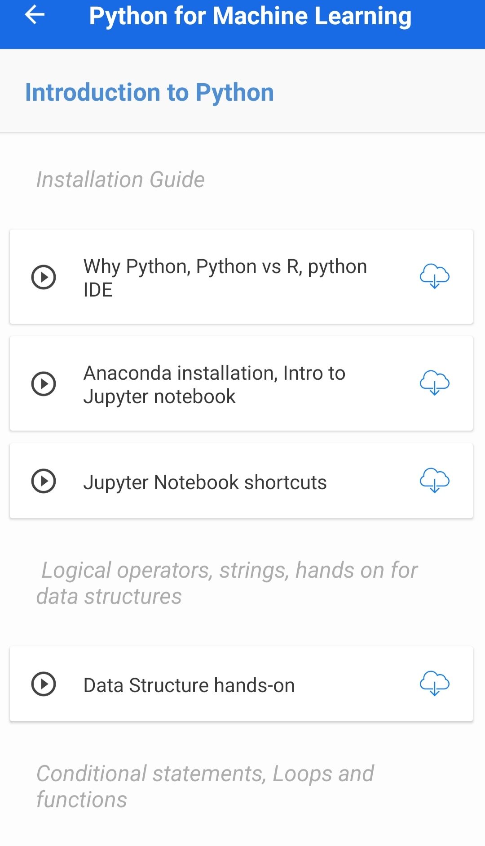

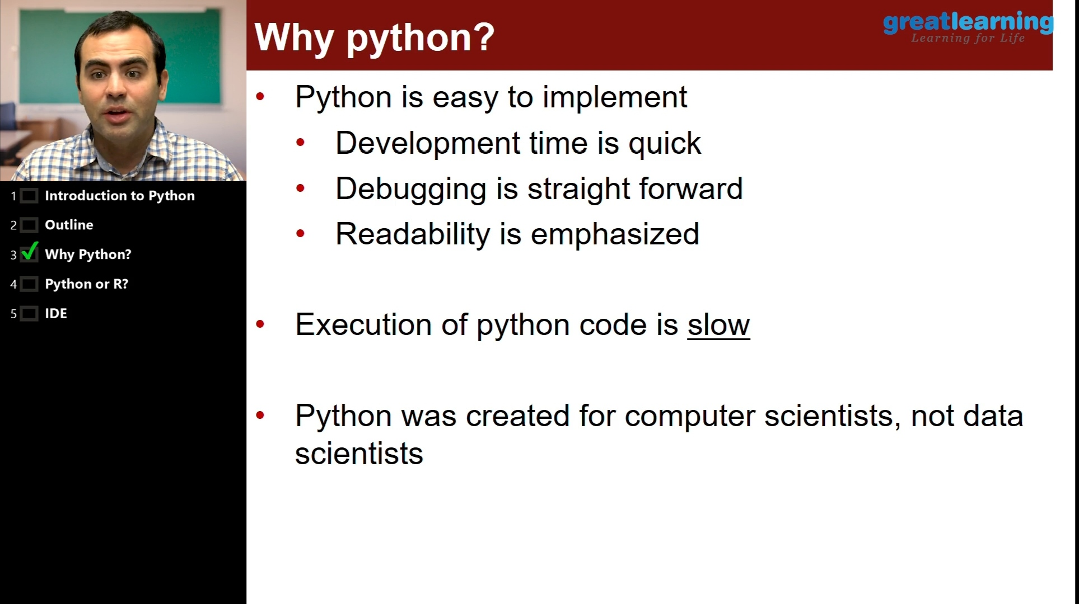

**Coding Challenges:**

Today I solved 1 coding challenge,

1. **Write a C++ Program to swap two numbers using friend as a bridge concept.**

